SILVERMILLS

**Game Design Document for:**

**Ransom**

Version 1.0

Nicole Silverthorn

Jeff Mills

May 10th, 2013

**Table of Contents**

1. Overview……………………………………………………………………………………………………………..3
2. Target Audience…………………………………………………………………………………………………..3
3. Target Platform……………………………………………………………………………………………………3
4. Visual Style…………………………………………………………………………………………………………..3
5. Goal/Objective……………………………………………………………………………………………………..3
6. Story……………………………………………………………………………………………………………………3
7. Characters……………………………………………………………………………………………………………4
   1. Hunter……………………………………………………………………………………………………...4
   2. Madcap…………………………………………………………………………………………………….5
   3. Level 1 Boss – Scorpion…………………………………………………………………….............6
   4. Level 2 Boss – Swamp Monster…………………………………………………………………7
   5. Level 3 Boss – Serpent………………………………………………………………………………8
   6. Level 4 Boss –Yeti………….…………….……………………………………………………………8
   7. Level 5 Boss – Rock Golem …………..……………………………………………………………9
   8. Level 6 Boss –Android………………………………………………………………………….…10
   9. Level 7 Boss –Solar Raven…………………………………………………………………….…11
   10. Level 8 Boss –Tree Monster…………………………………………………………………….11
   11. Level 9 Bosses………………………………………………………………………………………...12
       1. Madcap Revealed…………………………………………………………………………..12
       2. Ancient Weapon……………………………………………………………………………12
8. Combat/Weapons/Armour………………………………………………………………………………...13
   1. Combat…………………………………………………………………………………………………….13
   2. Weapons………………………………………………………………………………………………….13
   3. Armour………………………………………………………………………………………………........15
9. Game Mechanics………………………………………………………………………………………………...16
10. Levels……………………………………………………………………………………………………….………17
11. Puzzles……………………………………………………………………………………………………………...22
12. Cut Scenes/Cinematics………………………………………………………………………………………23
13. Interfaces………………………………………………………………………………………………………….24

13.1 Game Flow and Menus……………….……………..…………………………………………….24

13.2 Controls………………………………………………………………………………………………….25

1. Audio……………………………………………………………………………………………………………….26

**1 Overview**

Upon returning home from another expedition, a treasure hunter finds his house ransacked and his family missing. What he does find is a small map with a note on it. It states he is to find pieces of an ancient Aztec weapon to trade for his family. Hunter recognizes the weapon and knows what it is capable of when it is complete. He must save his family and destroy the weapon to save the world. This is an avatar-based, single player game. It falls under the adventure genre. The open world concept allows for searching for weapons or armour, fighting NPC’s, and finding occasional hidden puzzles. Fight sub-bosses and collect weapon pieces to advance through the levels.

**2 Target Audience**

The target audience includes the adolescent and teenage age groups (roughly 10-18 years of age), male and female. The desired rating from ESRB is E10+, for everyone 10 and older.

**3 Target Platform**

The target platforms are home game consoles and handheld devices, including mobile and wireless devices.

**4 Visual Style**

This game will be viewed from the third-person perspective. There will be 3D graphics used as well as some 2D graphics used, in the shell menus for example.

**5 Goal/Objective**

The overall goal of this game is to retrieve hunter’s family from Madcap. He first has to collect the 8 required pieces of the ancient Aztec weapon. Then, he must destroy the weapon as well as defeat the end boss to get his family back.

**6 Story**

Hunter is an accomplished treasure hunter. One day, he is returning home from another one of his expeditions, and his front door is wide open. He runs inside to find his house totally destroyed and his family not there. They always welcomed him home. Panicked, he looks around and finds a small piece of paper. It is a small map with a note written on it stating “This map has the location of pieces of an artifact you are to retrieve for me if you ever wish to see your family again. I will be watching. Signed, Madcap.” Upon further examination, Hunter recognizes this artifact as a weapon of mass destruction when it is complete. Now angry, Hunter quickly looks through what is left in his house and finds only a single weapon, a machete. He sets out following the hard to read map left by Madcap. Hunter must either get around or fight lunging static objects in different environments while he is searching for weapons or armour needed to defeat a sub-boss. When the sub-boss is defeated, Hunter can then collect a weapon piece that the sub-boss drops. After all 8 weapon pieces are collected, Hunter can then confront Madcap. When Hunter reaches him, it shows him handing over the 8 pieces of the weapon and Madcap quickly trying to put it together. That’s when the first part of the final fight begins. Just as hunter thinks he has Madcap defeated, it cuts to Madcap completing the weapon and firing at Hunter (missing, of course). This is when the second part of the final fight begins. Hunter must now destroy the weapon as well. After an intense battle, the weapon is eventually destroyed and Madcap is finally defeated. Madcap then flees. Hunter opens the door to the dungeon that Madcap had been guarding to finally find his wife and son. It is a happy reunion until they hear the echoes of Madcap’s voice, “You haven’t seen the last of me yet…”

**7 Characters**

7.01 Hunter

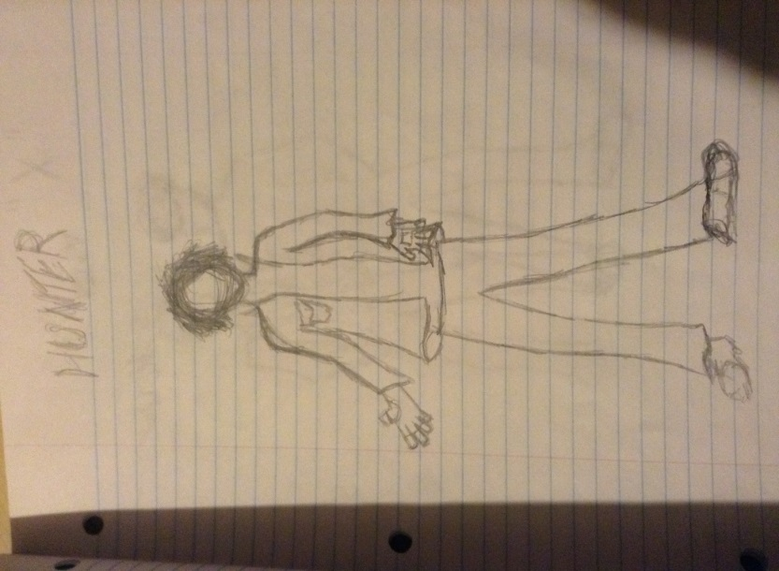

Main character

6’2”

185 lbs.

7.02 Madcap

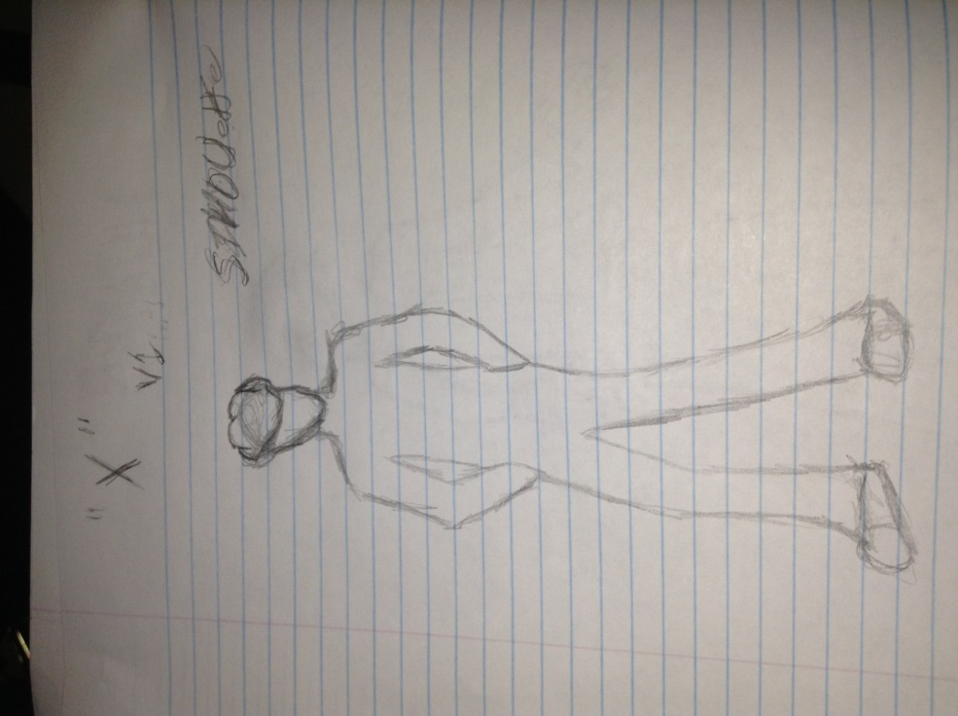

Villain

5’10”

160 lbs.

7.03 Level 1 Boss

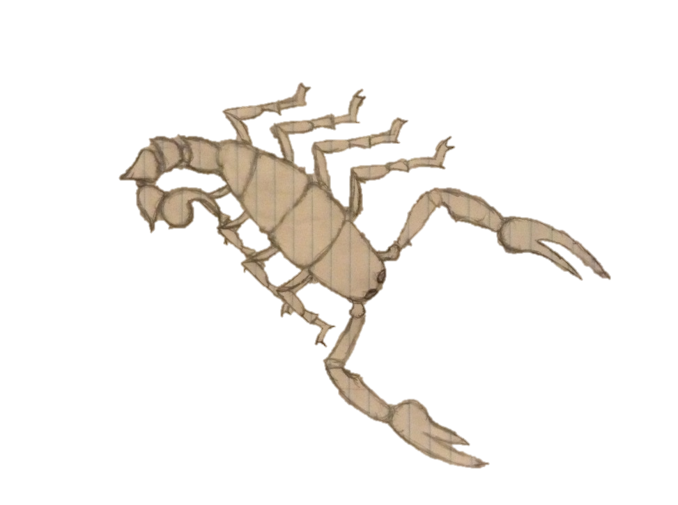

This beautiful monstrosity is a crystal clear scorpion that can refract sunlight with its tail to fire lasers at those who may wish to cause it harm.

Attacks

* Laser
* Grab
* Sting
* Smash
* Swing
* Trample

Scorpion

Drops piece of tail.

7.04 Level 2 Boss

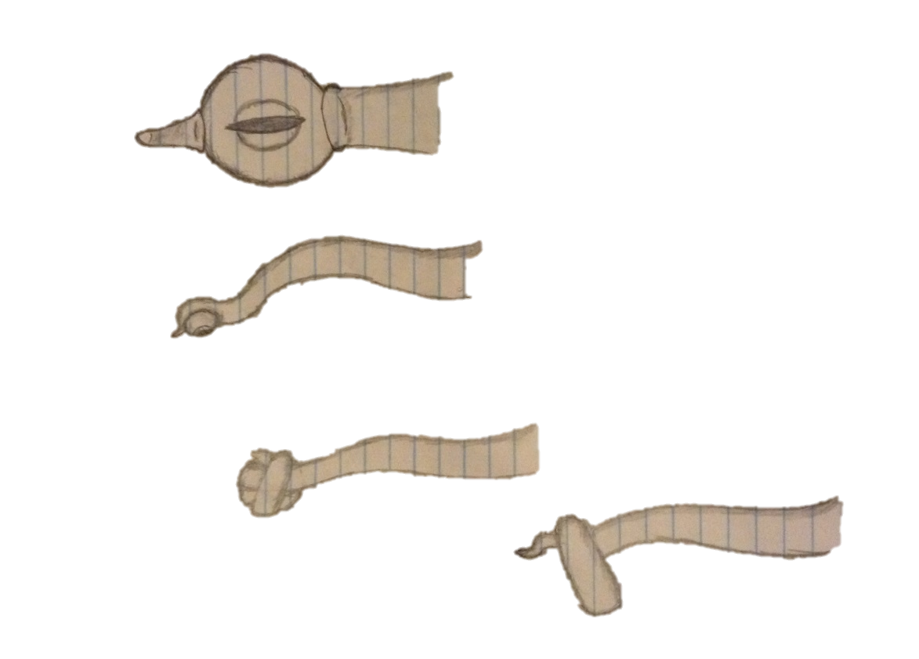

Multiple tentacles come out of the swamp to attack; the one main tentacle has an eye. Attack this when you get the chance to take out the main health bar to defeat it.

Attacks:

* Grab
* Smash
* Trip
* Whip
* Flash

Sea Monster

Drops Eye

7.05 Level 3 Boss

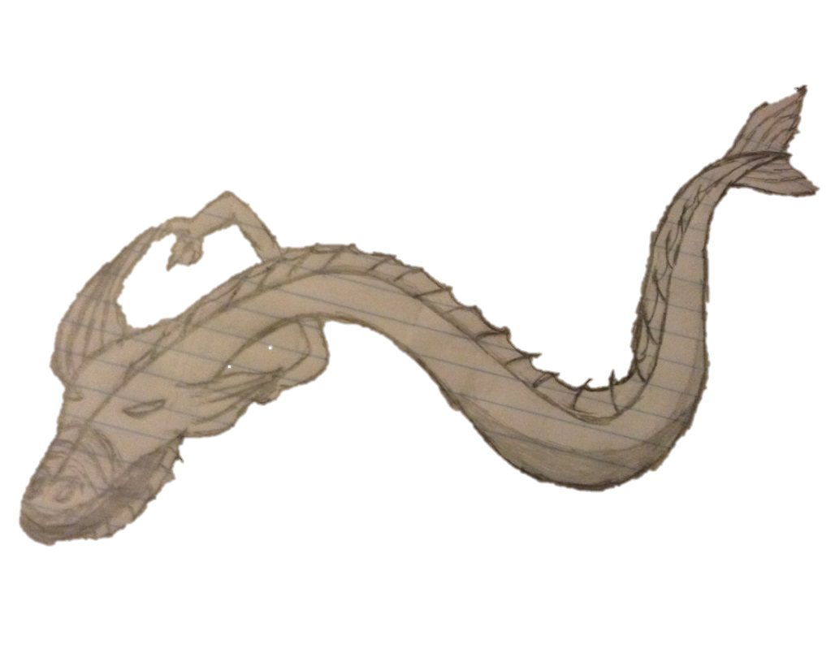

A serpent that can take out ships with the wrath of it powerful body

Attacks:

* Mist
* Freeze
* Slam
* Slash
* Air Dive
* Bite
* Wave

Serpent

Drops Body

7.06 Level 4 Boss

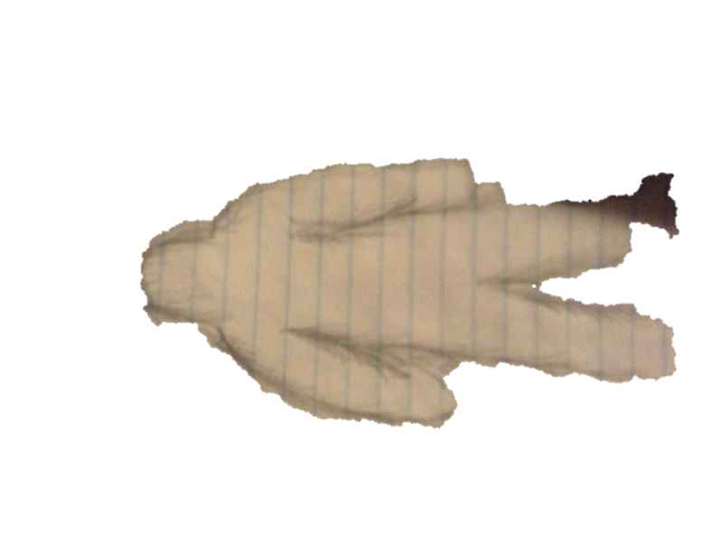

A mysterious creature that uses its natural ability to not be detected and unbelievable strength to remain anonymous.

Attack:

* Decoy
* Daze
* Punch
* Ice punch
* Ground Pound
* Snow burial
* Ice throw

Yeti

Drops Arms

7.07 Level 5 Boss

This beast can re arrange his body of Boulders as well as add to it or take away to change his size and shape, the only core stone is the one that controls the rocks in is made of and close surrounding rocks. To defeat this monster attack the glowing life stone.

Attack:

* Roll
* Rock slide
* Hammer fist
* Growth
* Disassemble
* Rock throw
* Crush

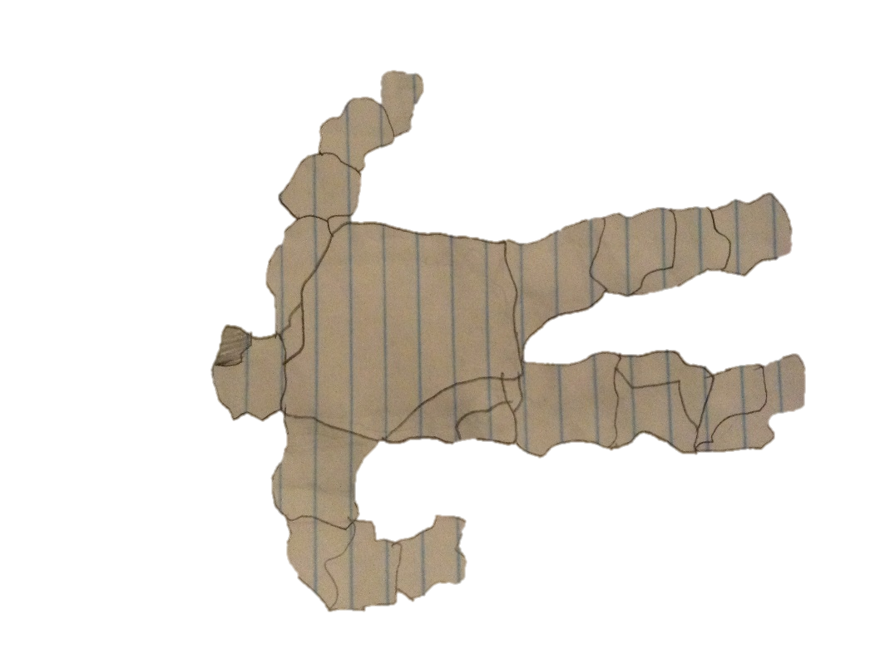

Rock Golem

Drops Life Rock

7.08 Level 6 Boss

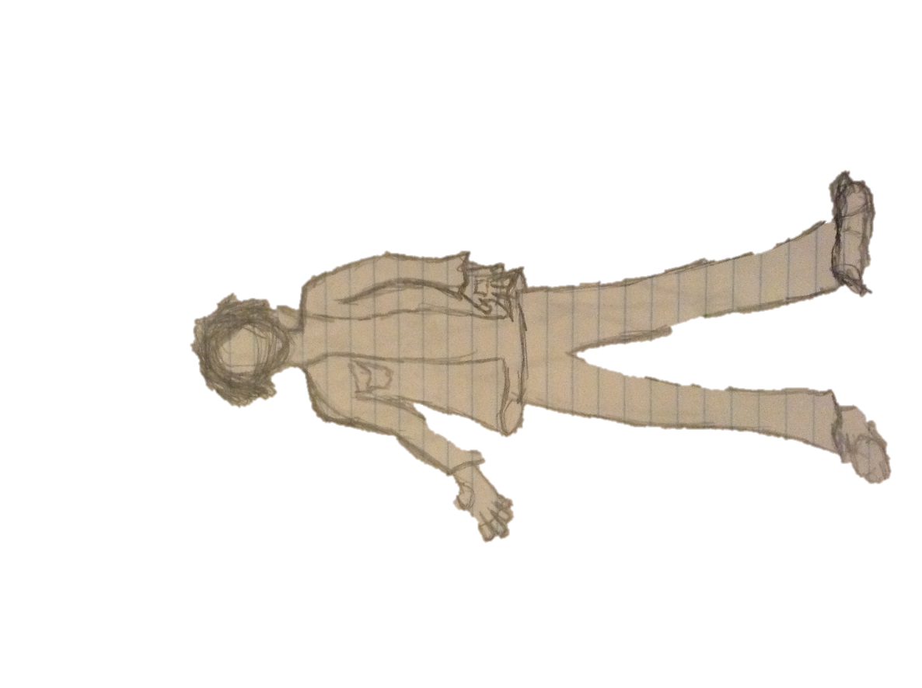

Not only does this robotic being look and sound like you, it also fights like you. But with its fight patterns being exactly yours and super human speed and strength as well it is probably a good idea to keep your distance with this one.

Attack:

* Punch
* Machete
* Handgun (Basic)
* Assault rifle (Basic)
* Charge tackle
* Choke

Android Hunter

Drops Control Chip

7.09 Level 7 Boss

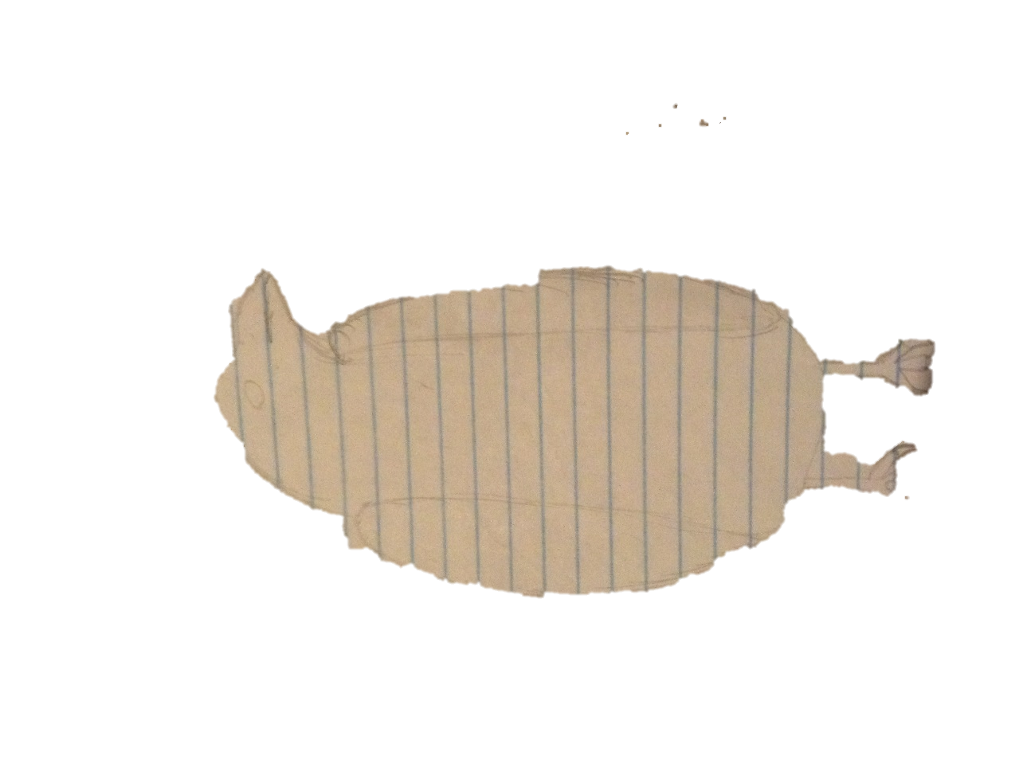

Size is not the only weapon this bird has against you, it can use its wings to gather solar rays to charge attacks or shoot energy balls at you.

Attack:

* Gather sun
* Charge
* Swoop
* Claw
* Gust
* Peck
* Sun Blast

Solar Raven

Drops Wings

7.10 Level 8 Boss

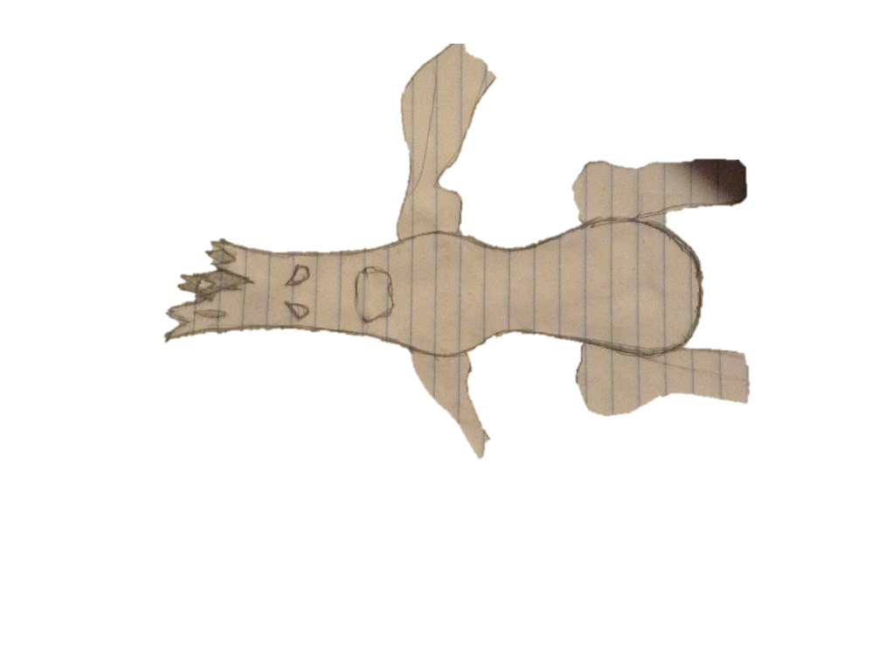

This monstrous tree seems a little out of place in a jungle; it seems to be a very violent and destructive creature. The hallow dead Trunk it has makes it pretty hard to miss amongst the green of the jungle but it’s almost impossible to escape from

Attack:

* Smash
* Root Grab
* Swing
* Tree throw
* Charge
* Trample
* Stab

Tree Monster

Gives Body

7.11 Level 9 Boss

7.11.1 Madcap revealed

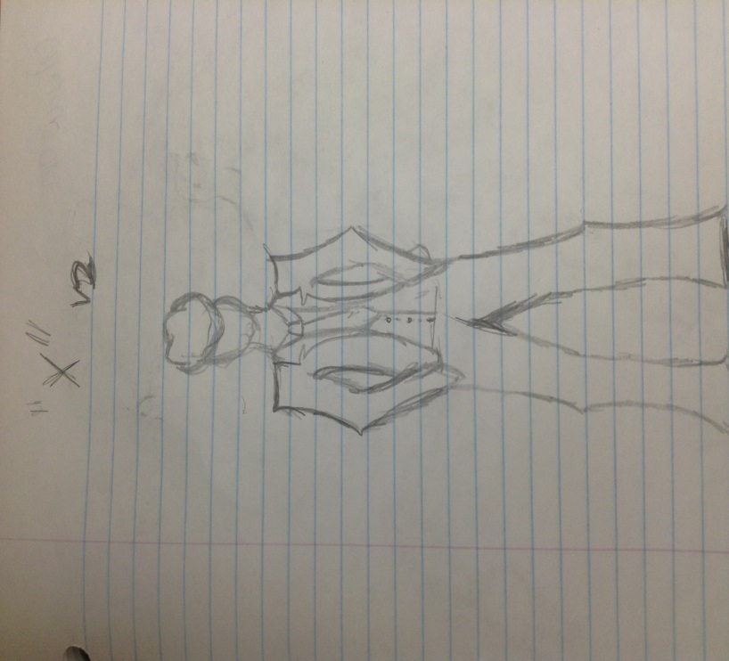

7.11.2 Ancient weapon

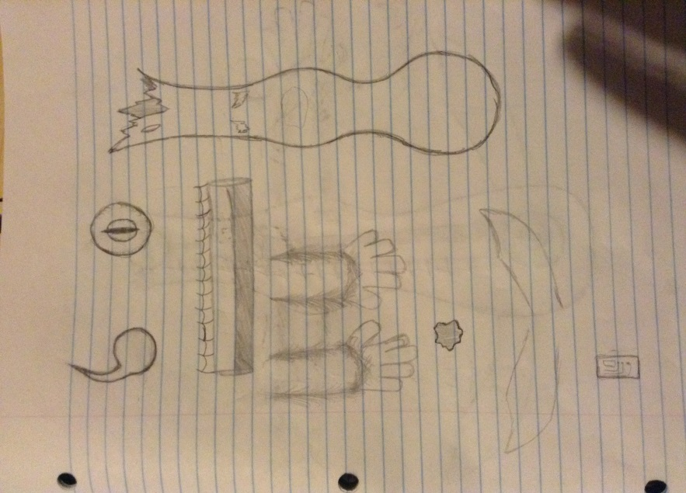 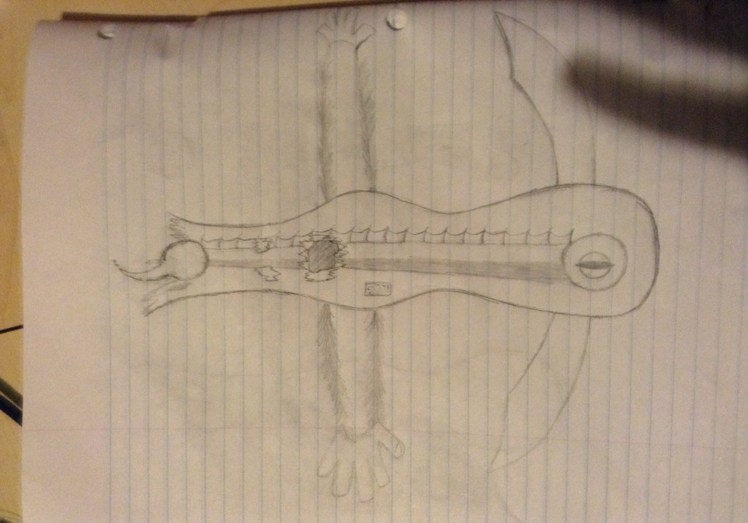

The different terrains will also have static objects (such as trees or vines) that will lunge and try and attack Hunter if he gets too close.

**8 Combat/Weapons/Armour**

8.1 Combat

Combat and fighting in this game will be done free-roam. Hunter can use his collected weapons to fight enemies. Choose a weapon from the inventory to swing high or low to hit enemies of all kinds. Hunter is also capable of blocking attacks from enemies with his equipped weapon.

8.2 Weapons

Hunter can only hold one weapon at a time but he can collect an unlimited amount. He can also switch weapons at any time with ease. Below is a list of weapons Hunter can find:

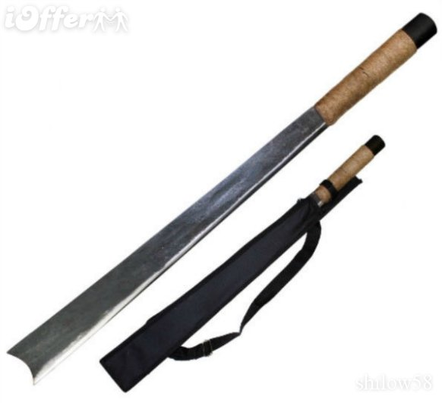

Machete

Starting weapon, found in level 1

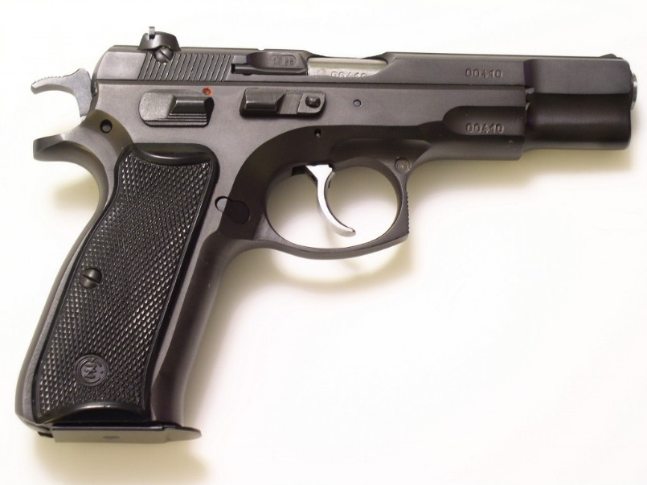

Hand Gun

Found throughout the levels in various looks and power levels



Assault riffle

Found in various places in many different styles and power levels

8.3 Armour

There are also 4 extra pieces of armour hidden throughout the levels that Hunter can collect and use for protection in combat.

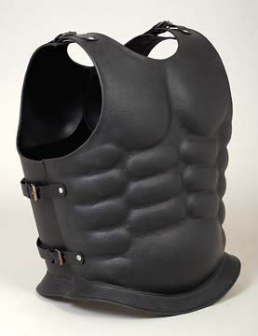

Vest (level 2)

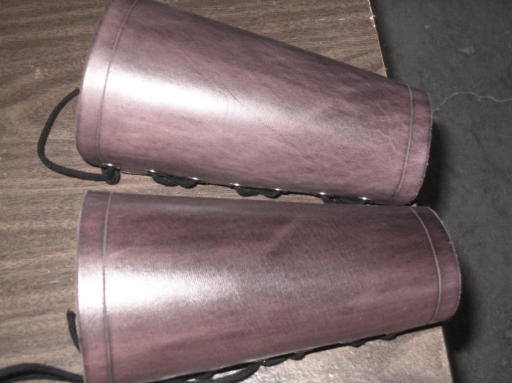

Vambrace (level 4)

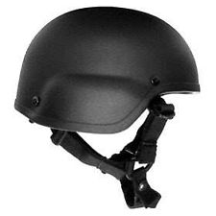

Helmet (level 6)

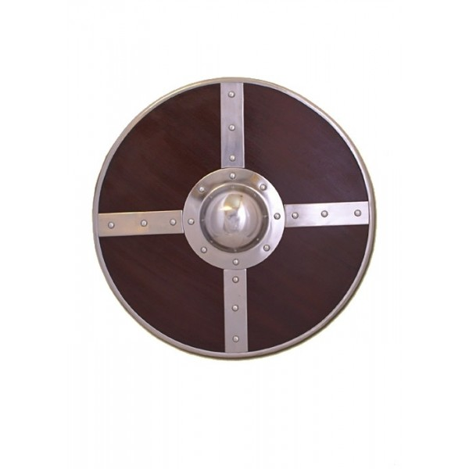

Shield (level 8)

**9 Game Mechanics**

The mechanics of this game include searching through 8 different environments looking to find either weapons, armour, or hidden puzzles. When found, weapons and armour are collected and kept in an inventory for use throughout the game. The game also includes active challenges where Hunter is to use these collected weapons to defeat enemies at certain spots in the levels. It also includes hidden puzzle challenges where upon completion (on the first attempt) the overall health bar will increase. A typical gameplay session would consist of Hunter walking around through different terrains being on the look out for any weapon or piece of armour found on the ground. Pick up the object when Hunter is touching it with the action button. He also must be on the look out for small static parts of the terrains (i.e. trees or vines) that can lunge to attack and decrease his health bar. He can either avoid static enemies entirely to prevent any decrease in health or fight and defeat them to increase overall strength. Different parts of certain terrains will also open up to a puzzle challenge where completing/solving the puzzle on the first attempt will increase the size of the overall health bar. Near the end of each level is where hunter will encounter a sub-boss and will have to fight and defeat them with his collected weapons. If defeated, the sub-boss will drop a piece of the ancient Aztec weapon which Hunter is then to pick up as well. Collection of a weapon piece is the end of a level which is when the game will auto-save. Auto-save points are where Hunter would restart upon dying. As Hunter progresses, the levels do gradually get harder. The first play-through is played on easy difficulty and in subsequent play-throughs the difficulty increases to Normal, then Hard, then finally Very Hard. The final boss fight is essentially the same as fighting any sub-boss only it’s done in 2 parts. The first part of the fight ends when it appears that madcap is defeated, only to have him assemble the weapon pieces and attempt to fire it at Hunter. This leads to the second part of the fight where Hunter must now destroy the weapon as well as fight. Attacking and hitting the weapon will start to dismantle and eventually destroy it. Upon successfully destroying the weapon and defeating Madcap, Hunter can then retrieve his family. Completion of this game, depending on the amount of time spent searching, could take anywhere from 4-8 hours.

**10 Levels**

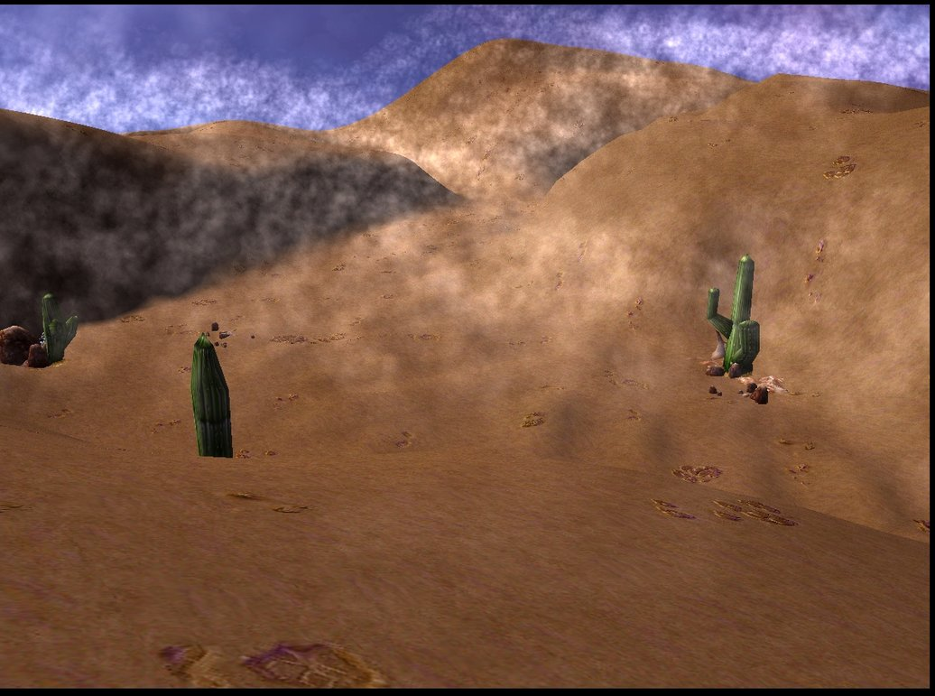

Level 1 – Desert

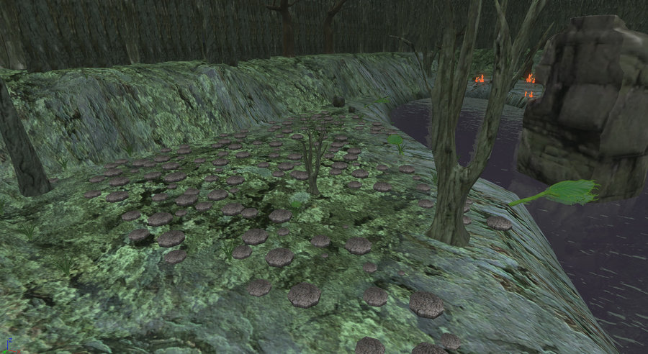

Level 2 – Swamp



Level 3 – Ocean

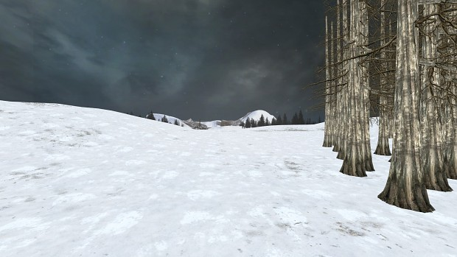

Level 4 – Tundra

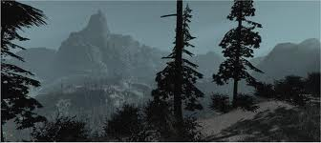

Level 5 –Mountain

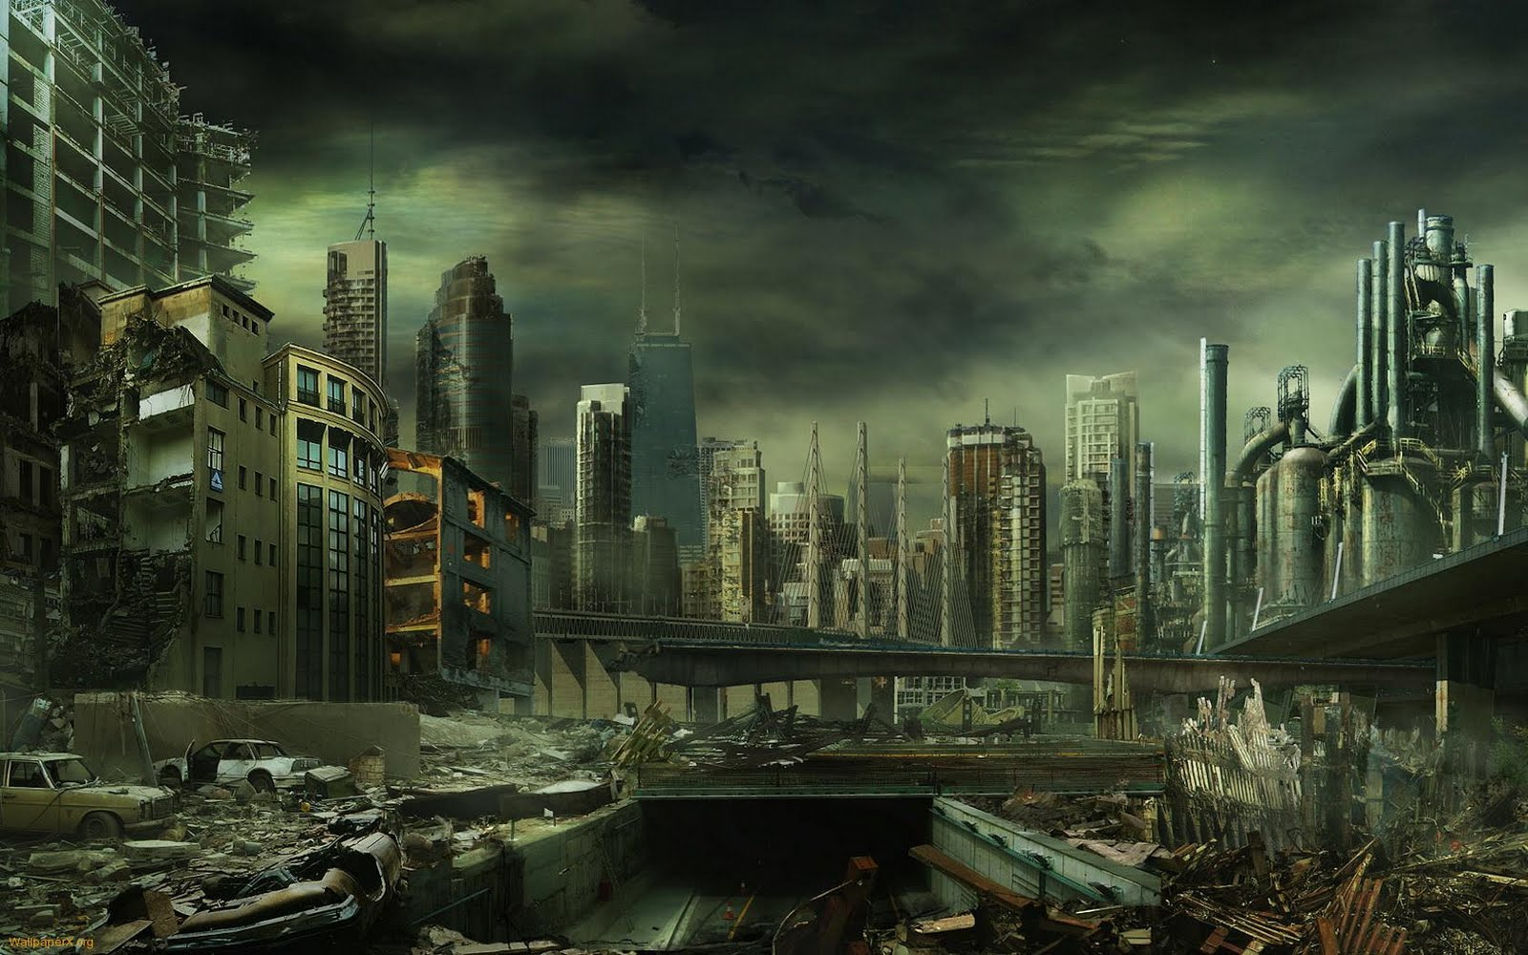

Level 6 – Destroyed City

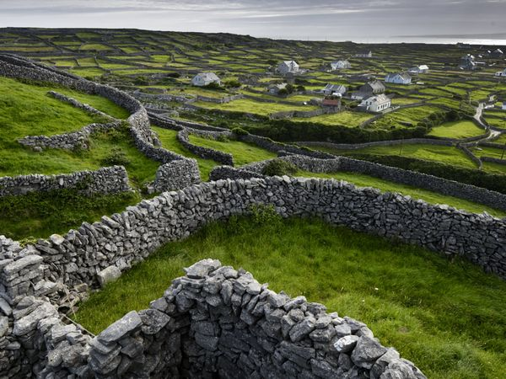

Level 7 – Plains

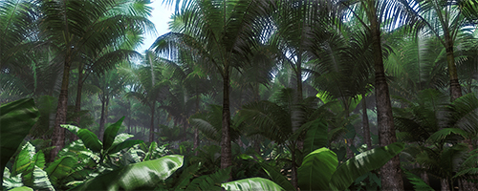

Level 8 – Jungle

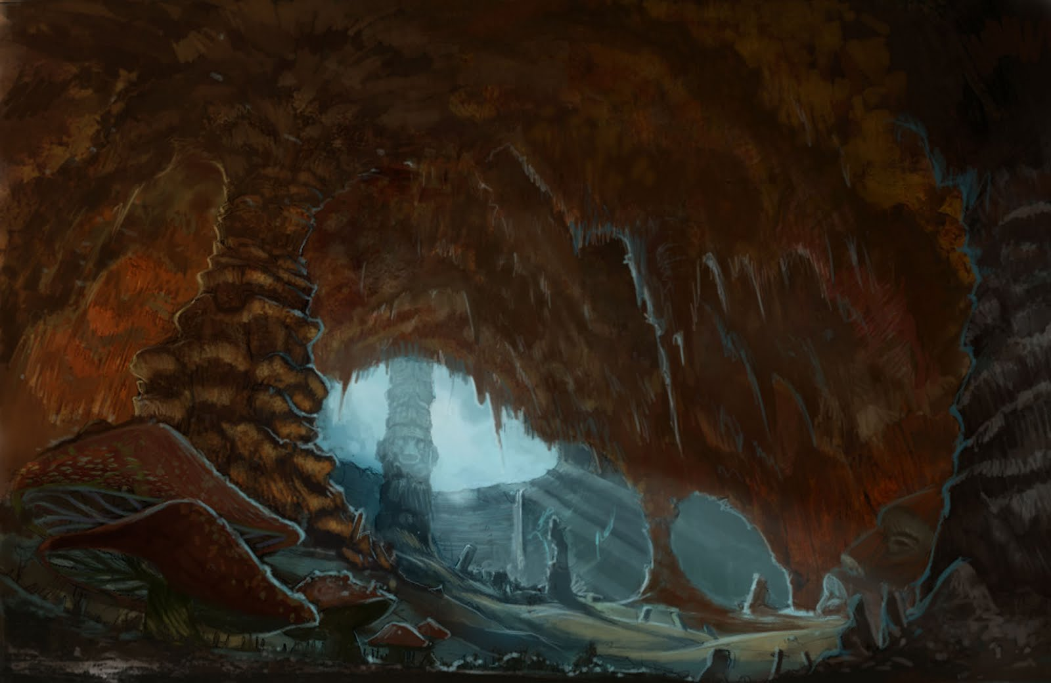

Level 9 – Cavern

**11 Puzzles**

Completing a puzzle will result in an increase in the size of Hunter’s overall health bar, only if it is completed on the first try. Puzzles can only be retried if the player chooses to restart the entire level (to previous save point). All puzzles will have a two minute time limit.

[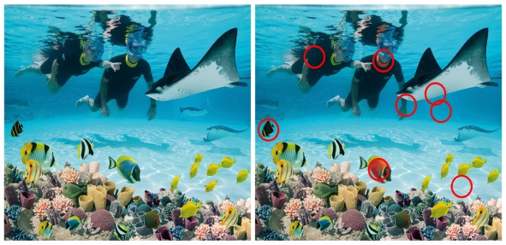](http://www.google.ca/url?sa=i&rct=j&q=spot+the+difference+with+answers&source=images&cd=&cad=rja&docid=tLtfNYX61zu4TM&tbnid=sUCDhLHpLvus1M:&ved=0CAUQjRw&url=http://background-pictures.feedio.net/sea-world-discovery-cove/photos.igougo.com*images*p165500-Sea_World-Discovery_Cove.jpg/&ei=uNaLUYSUHZCgyAGM54HwCQ&psig=AFQjCNFFjXgHSLr2MyDJGuSXBPsD7LSd1w&ust=1368205302832157)

Level 1 Puzzle (Find the differences) Solution

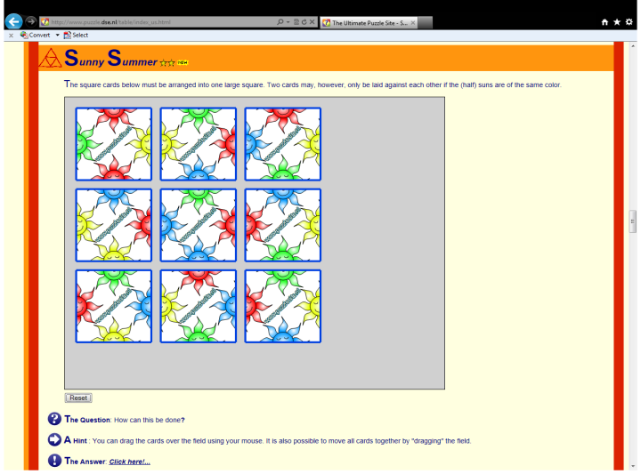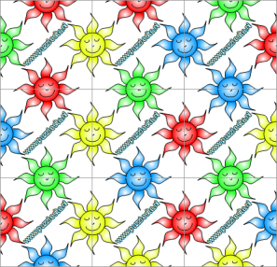

Level 3 Puzzle (Match up all the suns) Solution

[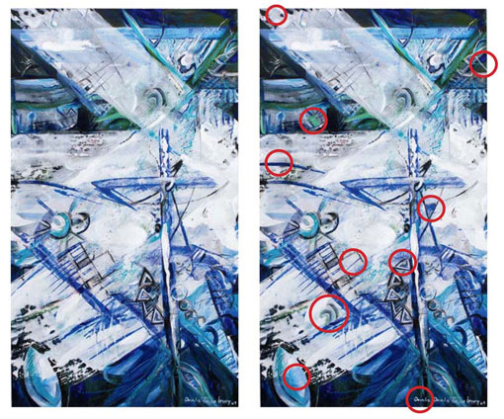](http://www.google.ca/url?sa=i&rct=j&q=landscape+spot+the+difference+with+answers&source=images&cd=&cad=rja&docid=1y99z_3QKkR8dM&tbnid=ykC6JLQshdZAnM:&ved=0CAUQjRw&url=http://www.nzlifeandleisure.co.nz/miscellaneous?page=2&ei=j9WLUa7PD4iBywH874CQCg&psig=AFQjCNHU079pg-5dsBKpc0uRKUPLA5MjYA&ust=1368205041656286)

Level 5 Puzzle (Find the differences) Solution

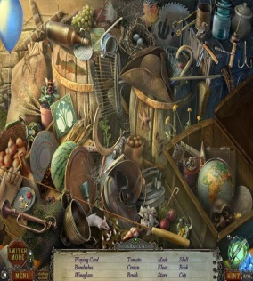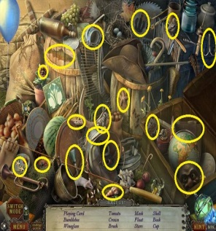

Level 8 Puzzle (Find the objects) Solution

**12 Cut Scenes/Cinematics**

This game consists of 4 cut scenes total. The first occurs at the game showing Hunter returning home, running into his ransacked house, and finding the note. You hear Madcap’s voice reading it. You then see Hunter quickly look around, grab his machete, and run back out the door. The second cut scene occurs at the start of the last level. This one shows Hunter hand over the weapon pieces and Madcap scrambling to put them together. Hunter demands his family now be returned. Madcap laughs. Then it cuts back to the start of the final fight. The third cut scene is after the first part of the fight when Hunter thinks Madcap is defeated. This cinematic shows Madcap lying motionless at first. He suddenly jumps up, puts the last piece of the weapon in place, and fires it at Hunter. It then cuts back to the second part of the final fight. The last cinematic occurs after Madcap flees, it shows Hunter opening the dungeon door finding his wife and son. As they are all hugging they hear Madcap’s voice echo “You haven’t seen the last of me yet…” Cue end credits.

**13 Interfaces**

13.1 Shell Menus – All menus will appear in full-screen

Game Flow Chart

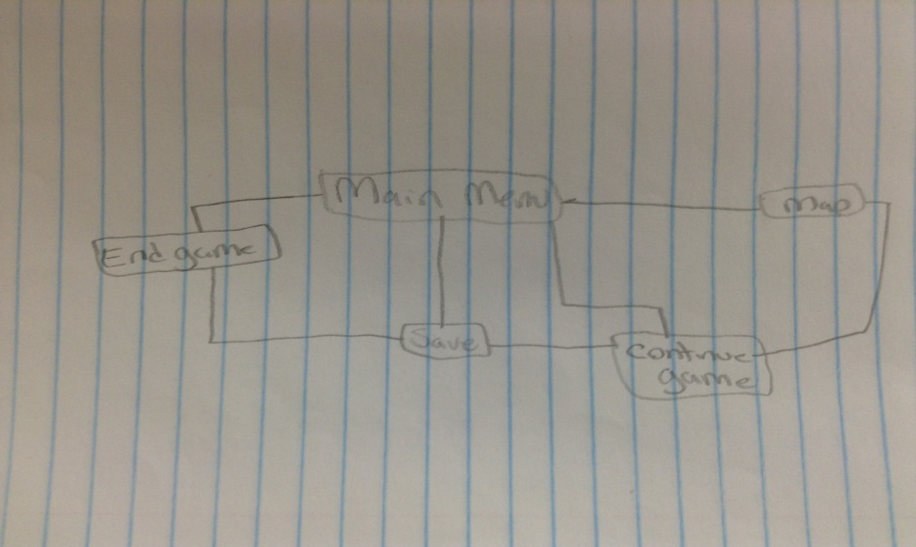

Map Menu

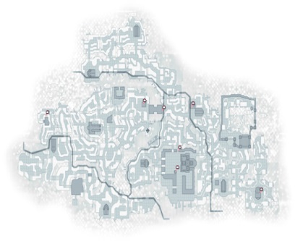

13.2 Controls

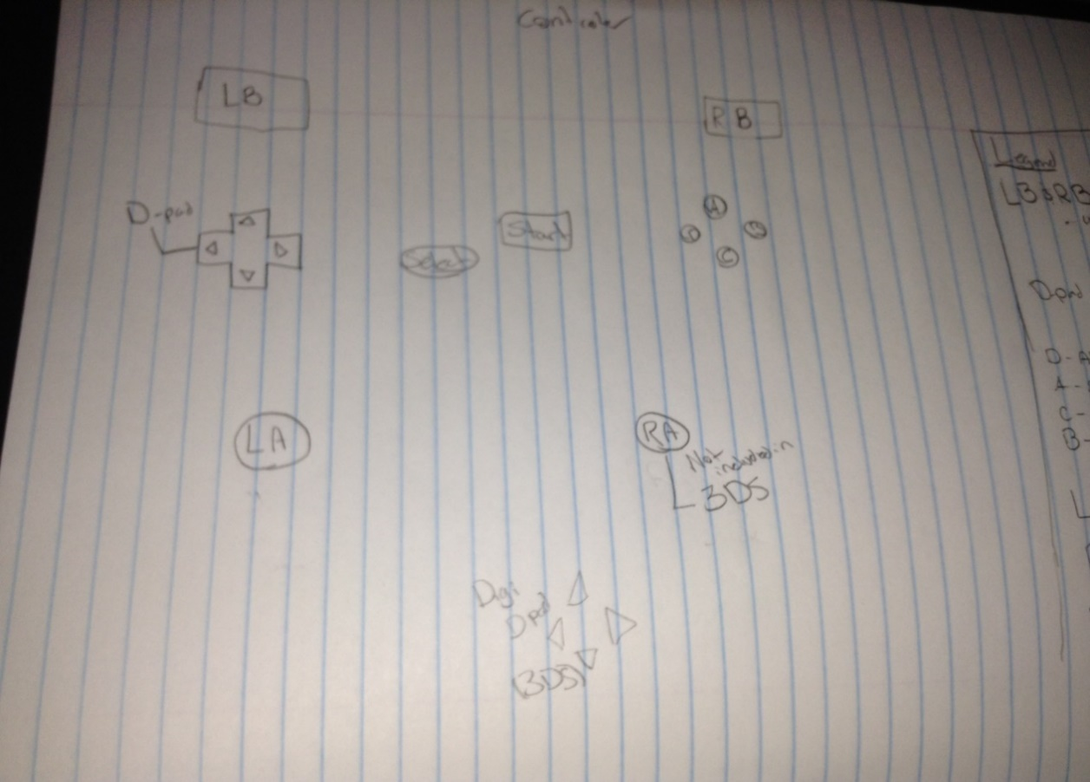

Consoles

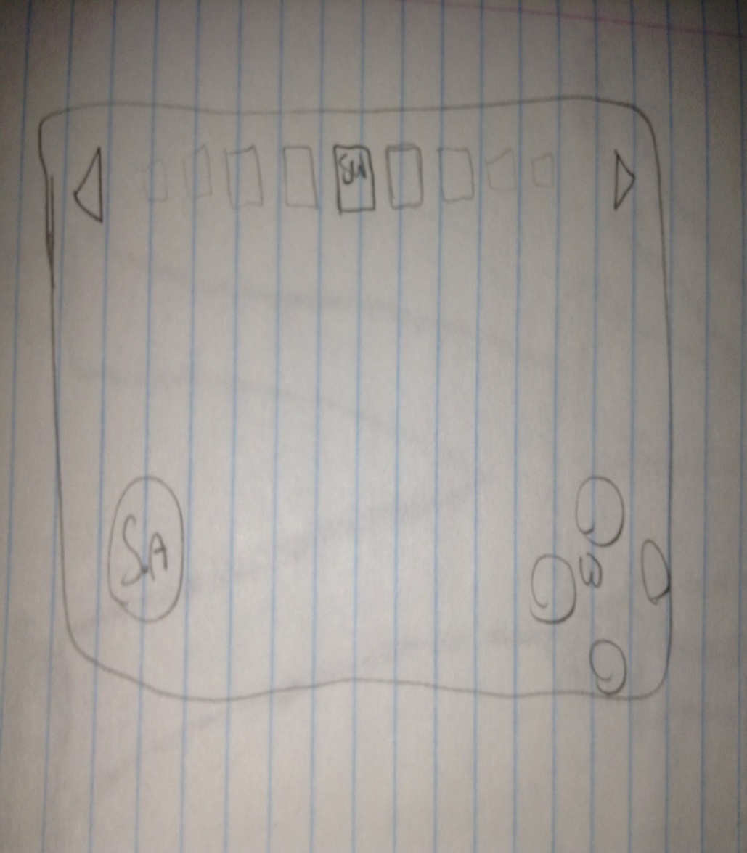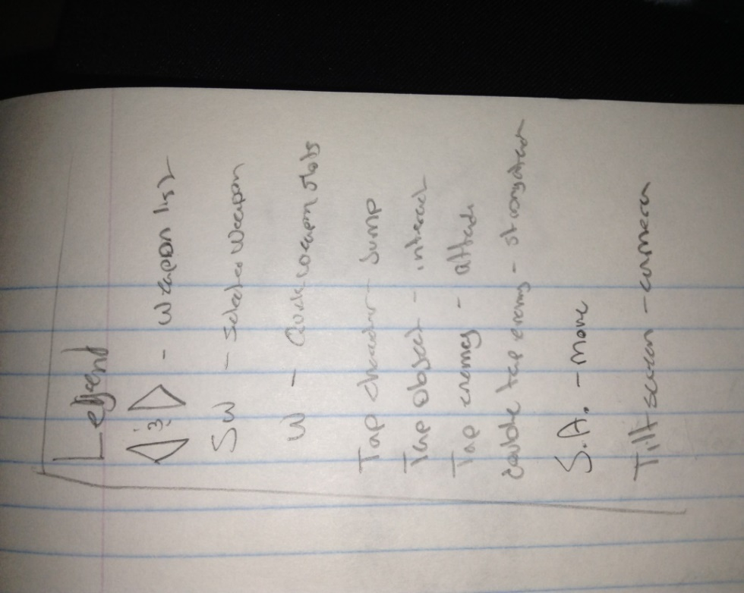

Touch Screen / Mobile Devices

**14 Audio**

All sounds in the game will have the option of adjusting the volumes or turning them off entirely. The style of music used will be instrumental and suspenseful. Sound effects will be used when Hunter walks, when he picks up an object, when a puzzle is completed, and when weapons collide or fire. Voice-overs will also be used for Hunter and Madcap’s dialog. Phrases said in Hunter’s voice will also be used if a player goes too far searching (reaches the edge of the world) such as “Nothing over here,” or “Oops, too far.” Also when a player has been inactive for a length of time (not on pause) Hunter will say something like “You still there?” or “Where’d you go?” Hunter will also say “Yes!” or “Nice!” when he picks up an object.